The Three Crosses
Painting the Easter theme based on Rudolf Steiner’s original of 100-years ago

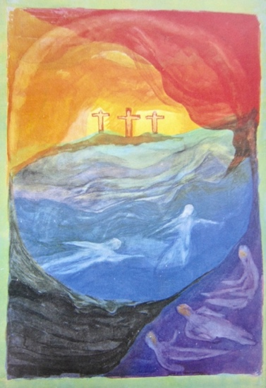
The Three Crosses

On the centennial of this picture an online painting session will work with the formative color story of The Three Crosses by Rudolf Steiner and will explore the connection with the festival time of year: Easter/Spring. This was one of the late watercolor paintings created by Rudolf Steiner in connection with a deepening of his work in Spiritual Science and the significance of the cycle of the year in relation to the human soul.

On Saturday evenings in the US and Sunday mornings in Asia, artist-educator Van James will guide beginners, intermediate and experienced artists through this color-imagination of the mystery of Golgotha as depicted in color. This is a practical painting workshops including illustrated conversation and discussion meeting on the weekend of March 23/24, 2024. No experience is necessary (have painting materials prepared and ready). A recording will be available. Contact Nurturer’Studio for more information and registration.

Sponsored by www.nurturerstudio.com
https://nurturerstudio.com/the-four-large-watercolors/

