藝術史教學 Teaching Art History
將內在生命融入以藝術、文化 意識與意識演化
Engaging the Inner Life with Art, Cultural
History and the Evolution of Consciousness
與Van James SAVE THE DATES請預留時間

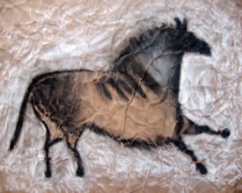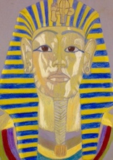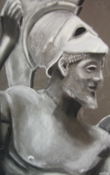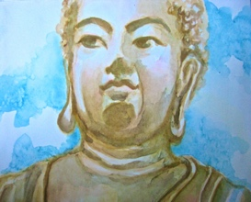

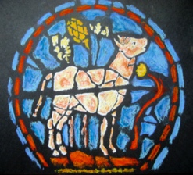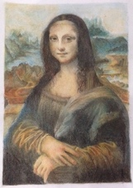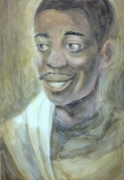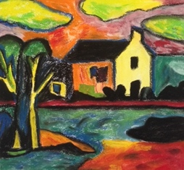

English recording with live Chinese translation
英語演講並提供中文翻譯回放
In Asia (English/Chinese): Thursdays, July 14, 21,
August 4, 11, 18, and Sundays, Aug. 28, September 11, 25.
亞洲時間(英語/中文)：
(週二)七月14日、21日、八月4日, 11日, 18日
(週日)八月28日、九月11日, 25日

“What had been revealed to me through spiritual perception
as the law of human evolution appeared in clear
manifestation before my mind in the development of art.”
– Rudolf Steiner, Course of My Life

通過精神感知向我揭示的人類進化規律，
在我的腦海中清晰地呈現在藝術的發展過程中。
-魯道夫施泰納，自傳。

Sponsored by NurturerStudio
本活動由NurturerStudio贊助
網址：https://nurturerstudio.com
電郵： nurturerstudio@gmail.com

