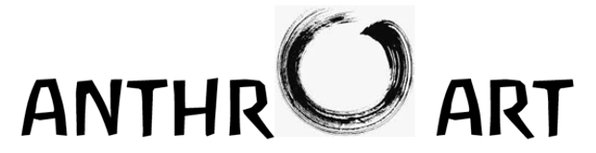
Shan Mei Zhen, Taichung, Taiwan
The Art of Color: A Head Study and Mother and Child Imagination after Rudolf Steiner’s Indications
Saturday, May 11 and Sunday, May 12, 2024
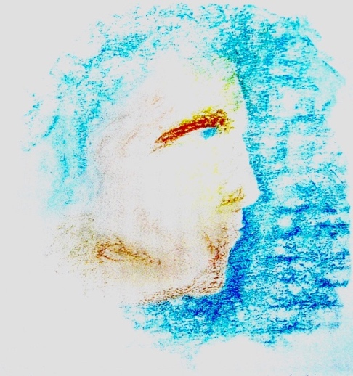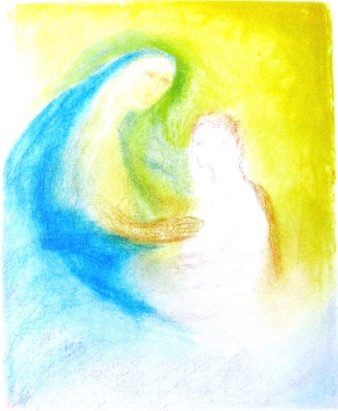
Head Study Mother and Child
As part of the AnthrOArt Painting Program at Shan Mei Zhen we are offering a weekend painting session on portrait and figure painting based on Rudolf Steiner’s indications of the Head Study and Mother and Child sketches for teenagers. The so-called Friedwart Sketches, given by Rudolf Steiner 100-years ago this year, are the basis for both high school painting exercises and an adult painting training. We will consider the history and makeup of these themes together with a hands-on approach of painting them, as much as possible, “out of the color”. We will likewise see how these sketches are visual meditative verses in color rather than in words. Illustrated slide presentations will be a part of the program and Color Eurythmy will complement the work in watercolor. We will see how the themes are a part of a larger initiative put forward by Rudolf Steiner for the unfolding of “artistic feeling” and universal human development.
This weekend course may be taken separately from the yearlong AnthrOArt Painting Program of which it is a part. Individual day-classes working with Rudolf Steiner’s further painting motifs (listed below) may be taken on a daily basis or the entire week may be taken as a whole. Contact: smz.waldorf@gmail.com

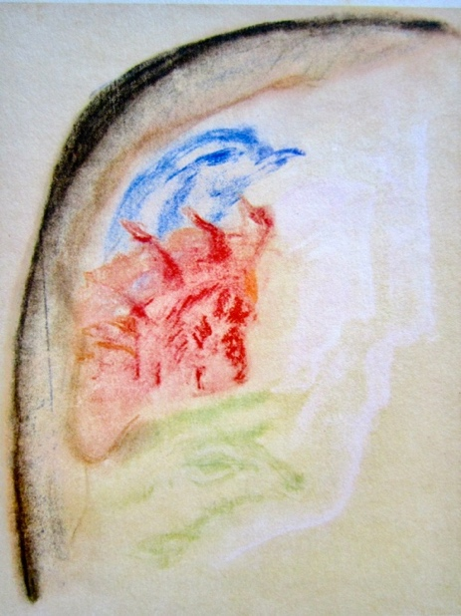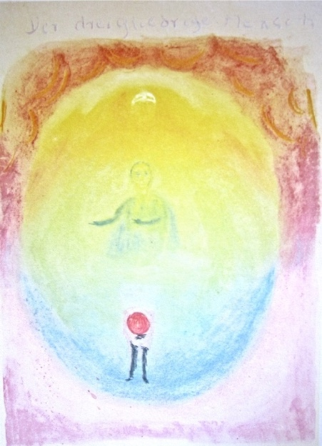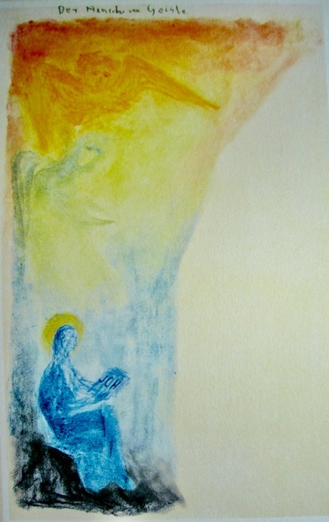
The Group Soul Threefold Human Being Human Being in Spirit
Monday, May 13, 2024
The Group Soul is a motif which brings together the Eagle, Lion, and Bull as pictures of soul forces at work in the Human Being. These were actual soul groupings of human souls in former times. We will paint this pastel sketch of Rudolf Steiner’s in watercolor balancing the color composition as one would harmoniously bring together the soul capacities of Thinking, Feeling and Will in one’s own inner life. Color Eurythmy classes will complement this day’s work as will conversation, questions and review.
Tuesday, May 14, 2024
The Threefold Human Being is another theme that depicts our nature as three soul-spiritual powers in one unified entity. Again, the beingness of the color functions in cooperation with the soul forces at work in this imaginative picture of the human being as body, soul and spirit. Discussions and Color Eurythmy will further fill-out this imaginative content.
Wednesday, May 15, 2024
The Human Being in Spirit is a color sketch on the contemplation of the human “I” between the realm of light and that of darkness, between spirit and matter. We will freely render this “seed picture” into watercolor and experience the range of polarities and enhancements in the color motif. A slide presentation with conversation and Color Eurythmy will be a part of the day’s program as on the previous and the following days.

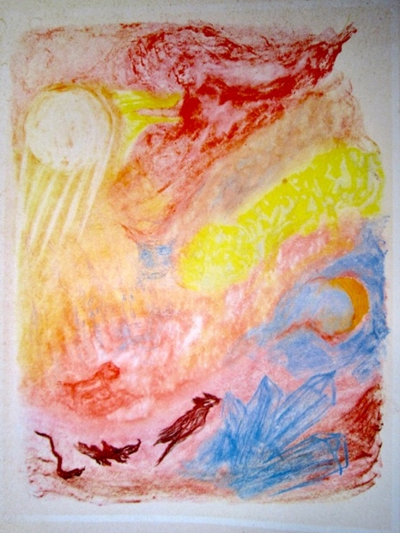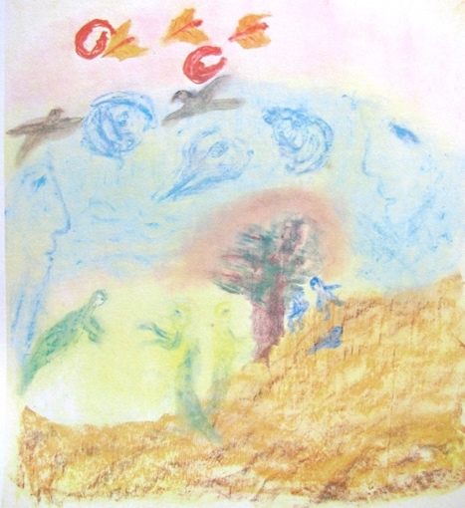
Johanni Imagination (Mid-Summer) Elemental Beings
Thursday, May 16, 2024
The Johanni Imagination or Mid-Summer theme is a challenging composition in that so much is going on in it. A wide range of forms and figures come into play out of the dramatic action and color movement. It is a festive summer scene with mythic, dreamlike imagery. An illustrated talk, conversation and Color Eurythmy will complement the day’s activities.
Friday, May 17, 2024
The pastel sketch of Elemental Beings playfully depicts the spirits of earth (gnomes), water (undines), air (sylphs) and warmth/light (salamanders). These are the beings that aid in the life support of our planet so that minerals, plants, animals and human beings may develop and thrive toward further evolutionary stages. They live and breathe in the beingness of color itself. Discussions, illustrated presentations and Color Eurythmy are a part of this and all the daily sessions.
A review of the week’s work and a looking forward to the summer and autumn online painting sessions of the AnthrOArt Painting Program will conclude the i-person series.

smz.waldorf@gmail.com

