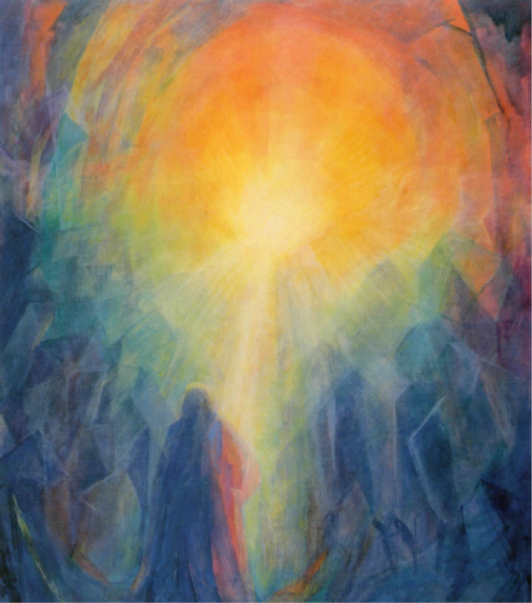
Palliative Care and Preparing for Death Workshop

Confronting death can be overwhelming if we are not prepared. However, by developing deeper insights, accompanying the dying becomes a unique experience that brings a sense of reverence and fulfilment. This workshop highlights home nursing care practices throughout the death process whilst creating meaning through ritual. We will consider the planning of after-death care options, including the three day vigil. The aim of the workshop is to share information so that more informed and personal choices can be made in the emerging field of community death care.

Saturday and Sunday July 30th and 31st 2022
Venue: Bellingen Youth Hub, 2 William St Bellingen NSW 2454
Registration form on last page
Saturday Program

9.00 am Acknowledgement to Country
9.05 am End of Life care Planning presented by Lisa Harris.
9.30 am History of the three day vigil presented by Charlotte Rogers.
10 am NSW legislation on death and dying presented by Lisa Devine.
10.30 am Anthroposophical nursing care perspectives presented by Charlotte Rogers.
11.30 Morning tea
12 noon Introduction to Dadirri, creating a deep listening space for the dying and the
community of carers including family and friends, presented by Beth Wrigley.
12.30pm Facilitated family conversations and a guided visualization, presented by Wendy Harfield.
1pm LUNCH
2 pm Ritual and Ceremony- presented by Lisa Devine.
3 pm Art pastel work led by Charlotte Rogers.
4 pm Afternoon tea
4.30-5 pm Circle reflection – creating a safe space and questions presented by Wendy and Beth.

Sunday Program

9 am Check in, questions & answers/conversation and introduction to sessions;
9.30 am Practical Demonstration – Laying out of the body: washing and anointing/oiling the body, clothing
and shrouding and attendance to the body during the three day vigil by Charlotte and Beth.
11.00 am Morning Tea
11.30 am Spiritual care perspectives of staying connected to our loved one led by Lisa Devine.
12.15 am Sharing lived experiences of pre and post-death care led by Wendy and Beth.
12.45 pm LUNCH
1.45 pm Questions & Answers/Conversations and Closing Ritual of honouring and reflection.

About the Presenters:
Charlotte Rogers: Anthroposophic nurse consultant, Anthroposophical massage and art therapist.
Lisa Devine: Ordained Priest of the Christian Community, Master of Psychology (Counselling).
Beth Wrigley: Registered Nurse, Masters of Indigenous Studies (Trauma & Healing). Beth works facilitating groups in organisations, community and in undergraduate nursing & midwifery academic spaces using circle work and Indigenous pedagogy (healing and education) practices, with a focus on story, deep listening and creative and expressive processes.
beth@ozemil.com.au

Wendy Harfield: Trauma therapist, Counsellor, Death Doula. Facilitator of Grief Tending Rituals.
In Wendy’s counselling practice she works very deeply with individuals using image-work, inner journey and sensorimotor psychotherapy, assisting people to find where trauma sits in their body, how it impacts their life and facilitating them towards self-awareness and change. wharfield@hotmail.com

Dr Lisa Harris: GP Proceduralist in Palliative Care with Anthroposophical Integrative medical training.

ANTHROPOSOPHICAL INTEGRATIVE PALLIATIVE CARE
As an anthroposophical palliative care circle our mission is to deliver holistic palliative care that encompasses the body, soul and spiritual aspects of the human being. We are a collective of human beings who have our spiritual home in the path of Anthroposophy*, and who work in various professional modalities at the threshold of death. This circle forms a source from which we draw, and to which we contribute in order to support each other and our work, and deepen and refine our understanding of care of the threshold of death.

What We Do
Members of the Anthroposphical* Palliative Care Circle work variously, as individuals and as part of initiatives, professionally and voluntarily in Australia. Currently this includes doctors, nurses, priests, counsellors, naturopaths, death doulas, art and massage therapists for home death care. We are working towards forming hospice facilities. What we have in common is an Anthroposophical* understanding of the threshold of death, and this is what informs how we work, though this work can be received by any human being, of any creed, that is, respectful and inclusive of all religions, spiritual beliefs or lack of.

*What Is Anthroposophy?
Anthroposophy is a spiritual path that can lead us towards becoming more fully human. It is path of knowledge and shared inquiry through research, about becoming ‘consciousness of our humanity’ at all levels: body, soul and spirit.
It is not a belief system but rather an individual path of spiritual development that finds fulfilment in study and community, through social, creative and practical initiatives. Thus, Anthroposophy requires an open heart and an enquiring mind.
Rudolf Steiner gave clear insights and guidance for all kinds of human activity, inspiring creative work in many fields including agriculture, medicine, education and the arts.

Integrative Community Palliative Care

Palliative Care and Preparing for Death Workshop
July 30-31st, 2022
At Bellingen Youth Hub, 2 William St Bellingen NSW 2454

Registration form:
Name………………………………………………………………………………………………
Address………………………………….………………………………………………………
Email address……………………………………………………………………………….
Phone (home) (mobile)

I wish to register for the conference at a cost of $125 [ ]
Or I wish to register at a supported position of $80 [ ]

Bank direct deposit to: C L Rogers
BSB 533-000 Account No. 10567945.
Include your full name on transfer

If you are direct depositing, please do so as soon as convenient, and by
July 28th 2022 at the latest.

Morning and afternoon teas will be provided.

Please indicate of you require: vegan [ ]
gluten free [ ]

Email your completed registration form/enquires to: crogers3@mail2world.com

