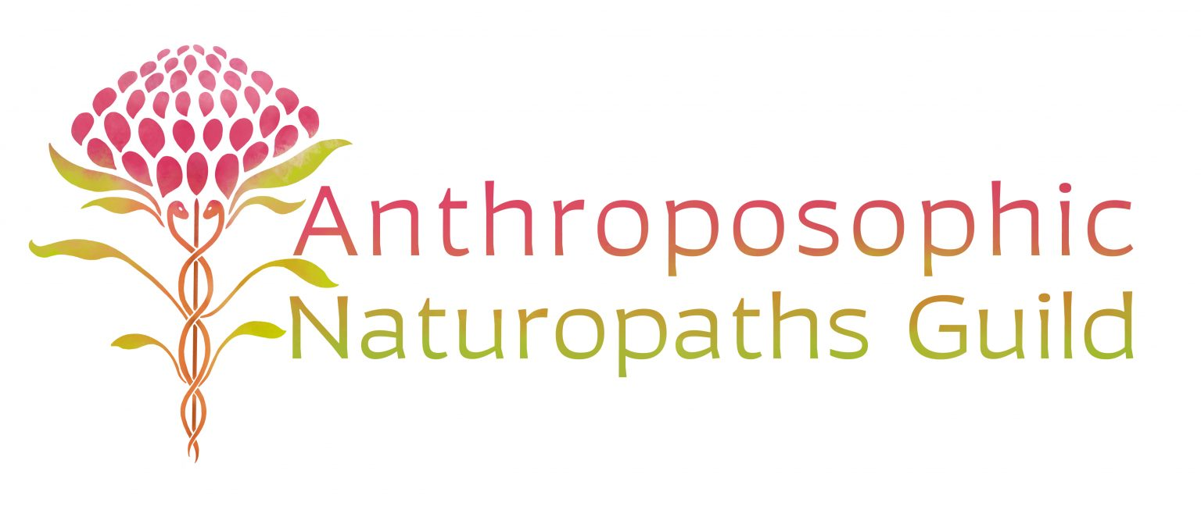

Anthroposophic Naturopathy – Advanced Training 2023:

Part One 2023: Pharmacodynamics and Remedies
- metal, mineral, plant, animal and organ remedies.

Monthly Webinars – the third Wednesday of each month from 7pm to 8.30pm

By working intuitively, inspirationally and imaginatively with the gesture of each Kingdom in Nature we can find the indications for the use of healing substances. Learning to seek higher forces that lie hidden in the processes underlying the formation of mineral, plant and animal leads to discovering that they correspond to those that need to be stimulated in the patient and the processes are the same as the ‘homoeopathising’ activities within the human being. These aspects are essential in order to achieve a genuine understanding of the remedy and its curative effects. A deeper intuitive insight into the nature of the forces within the substance (substance story) must be schooled through intensive spiritual-scientific research. This opens up a huge panorama for looking into the inner dynamic of remedies and illnesses. Goethean observation is the method by which you can let the phenomena speak to you through an intuitive power of judgement and can lead you to the Signature of the Remedy.

Please note that attendance of this training requires evidence of completion or attendance of approved orientation training in anthroposophic medicine/naturopathy. Participants who require endorsement will need to complete monthly assignments. Other interested persons may join the Webinar by application.

The cost per Webinar is $50 for qualified practitioners and $30 for students/interested persons, payable as you go or as a full amount for the 9 Webinars at $400. Payment details will be given upon acceptance into the Training.

To register please contact:
Irmhild Kleinhenz, anthroposophic naturopath, educator and mentor for Anthroposophic Naturopathy.
PO Box 197, Urunga, NSW 2455. Telephone: 0444 551 381, Email: naturosophy@pm.me

Please give me your information (why you wish to be an anthroposophic prescriber and some biography) and intention to participate in a written application. I will need your full professional details and references.

Mentorship for personal support is made by application to Irmhild.

This Course is approved by ANG (the Anthroposophic Naturopath Guild of Australia) and ISAN (the association of anthroposophic naturopaths) under the Anthroposophic Medicine Association, The Goetheanum, Dornach, Switzerland.

